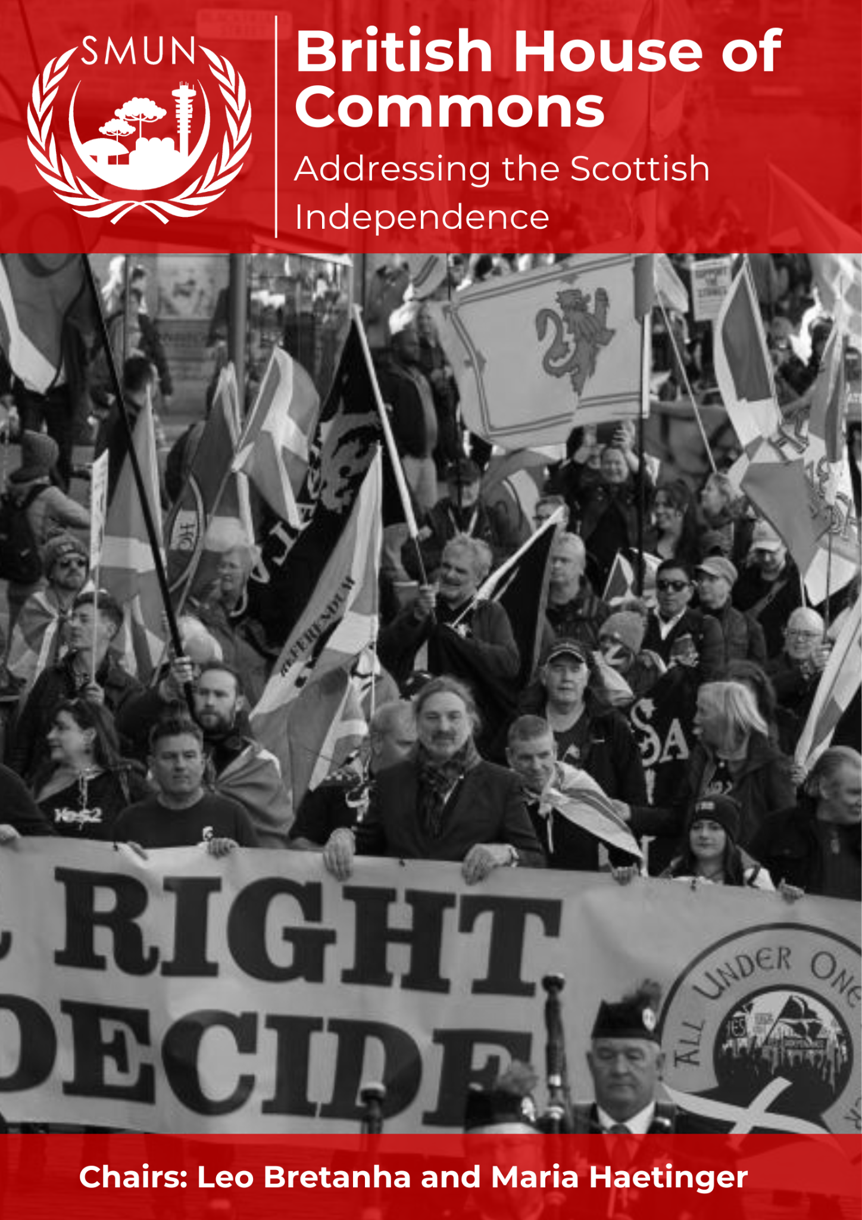

# 

# TABLE OF CONTENTS

**LETTER TO THE DELEGATES 2**

**COMMITTEE DESCRIPTION 3**

Historical background of the House of Commons 3

**PARLIAMENTARY PROCEDURE 4**

Writing Bills 5

Rules and customs 5

Traditions 6

Popularity index 6

Bill Sample: 7

Special notes: 7

**TOPIC: Addressing the Scottish Independence 8**

Historical background and current situation 8

Timeline of events 9

Position of Major Representatives 10

*Against the Independence 10*

*In Favor of the Independence (Scottish National Party) 13*

Guiding questions 15

Further research 15

**BIBLIOGRAPHY 16**

# LETTER TO THE DELEGATES

Dear MPs,

I am Maria Haetinger, a student from Escola Suíço Brasileira de São Paulo and it is an honor to be your Speaker during this year's SMUN. It is a pleasure to chair such an important committee as the House of Commons alongside my dear fellow chair Leo. This is a committee which requires a lot of preparation since the rules are quite different from the traditional ones, but I strongly believe that the debate will be one of the best that I have experienced in my MUN career so far. I hope that everyone has a lot of fun taking part in this conference and that at the end, all of you leave feeling accomplished by the things done inside the committee independently of the awards.

I am Leo Bretanha and together with Maria I will be your Honorable Mr. Speaker for this House of Commons. I am a student at Swiss School Curitiba and this is my 9th MUn conference, but this is only my second time as chair and it is a pleasure to be so. I want to thank you all who have chosen to debate on this special HOC as me and Maria have been preparing a lot and studying about it, it is not as easy as it sounds to debate in the UK House of Commons. Hopefully we will have fun, see some screaming between the MPs and come to a solution which will be proposed as a law about Scottish Independence. Remember, we are in 2014, so should Scotland leave, or stay in the UK? I guess that is up to you, MPs!

Sincerely,

**Maria Haetinger**

mariateresahaetinger@gmail.com

+55 (11) 99113-8628

**Leo Matsui Bretanha**

leo.bretanha@aluno.chpr.com.br

+55 (41) 99785-0277

# 

# **COMMITTEE DESCRIPTION**

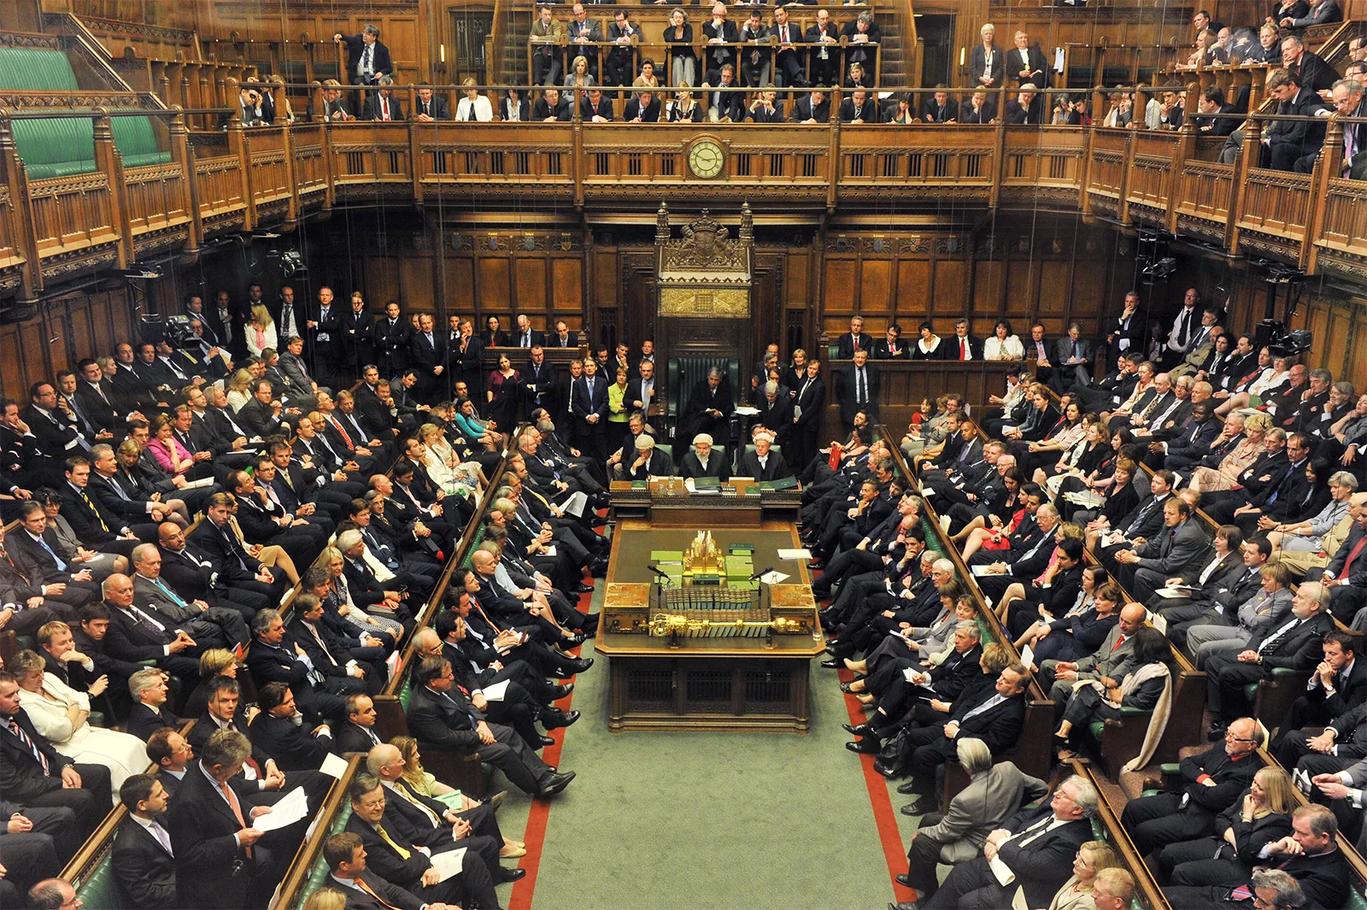

## Historical background of the House of Commons

This house, officially the Honourable the Commons of the United Kingdom of Great Britain and Northern Ireland in Parliament assembled, predates the foundation of the UK itself. It was founded as the House of Commons of the Kingdom of England in the 14th century by the Magnum Concilium, a royal council that advised the monarch during medieval times.

Commons was the less powerful of the two Houses for the subsequent centuries, with the House of Lords controlling most important measures. It was only in the late 17th century that Commons had gained sole rights to implement taxation measures, but Lords still maintained their veto power. That meant the only resource for the Liberal Party to pass its Reform Act to modernize the voting system in 1832, for example, was to threaten to flood Lords with new Liberal peers. That same tactic was used again eighty years later to approve the Parliament Act of 1911, which finally ended the Upper House's veto power (though it maintained its right to delay legislation by two years, lowered to one year in 1949).

# **PARLIAMENTARY PROCEDURE**

As the House of Commons has very different procedures from a normal committee, please pay attention to the stages in which the committee will happen. Firstly, an agenda must be established for the entire conference, addressing all the topics that the MPs want to discuss during the debate.

The discussion is always going to follow the Bills, therefore there will not be a separate time for argumentation that is not related to the draft Bill presented. It is expected that all the issues which need to be addressed on the issue, are going to be present inside the body of the text, therefore leaving no need for extra time.

These next stages must be repeated in the same order for each draft Bill written inside this committee:

**I. Bill writing** – The MPs will raise a motion for an unmoderated caucus and set a certain amount of time in order to write Bills on an agenda topic, with the intention of solving it. The Bills should be written by block, so it is expected by the Speakers (the chairs) that two draft Bills are presented at the end of the unmoderated caucus.

**II. First reading** – After the draft Bill is written, a motion to introduce the document should be raised and the title be presented to all MPs, together with the intention with which the document was drafted. The Bill is then made available to all other MPs to read.

**III. Second reading** – The debate on a draft Bill starts after a motion by any MP for a moderated caucus in order to do speeches regarding the Bill being presented. The first speech of this caucus must be of one of the 3 MPs responsible for the Bill (one main-submitter), who will deliver an in favor speech. The first speech must be followed by an Opposition MP doing a speech against the document. The MPs should decide which person is going to do such speech. After the two first speeches, any MP is welcomed to have the floor and present their point of view regarding the document. After each speech, if the MP is open to, other MPs are able to ask points of information.

There are no raising placards inside this committee, therefore, in order to MPs to talk during both the caucuses and the readings, the following is mandatory to the flow of the debate: there are no speakers list on this debating style, therefore MPs must attract the attention of the Speakers (chairs) by standing up briefly every time the next MP is about to be called, then the Speakers will choose one MP to do its speech. After that, the Speakers are going to ask if the MP is open to any points of information, if the answer is negative, the MP must sit again and another one can rise. The same has to be done for the points of information after the speech, but only if the MP who did the speech presents itself as open to points of information.

**IV. Committee stage** – On this stage, the MPs may raise a motion for a moderated, semi-moderated or unmoderated caucus. This is the stage where all the MPs should analyze the Bill presented and propose amendments together with its respective blocks (in favor or against the Bill). Every clause has to be agreed upon, changed or removed (through amendments) by the authors and signatories of the Bill in question in order to pass. There cannot be any opposition on the draft after the amendments.

**V. Report stage** – All MPs can speak and vote on the amends for the Bill, with speeches either in favor and against. Amendments will be voted on by the House as a whole and require ⅔ majority to pass.

**VI. Third reading** – The MPs should raise a motion for the committee to move into voting procedure on the amended Bill. The MPs, even though sharing the same opinions with others and being part of a block, vote independently.

## Writing Bills

In this committee, the Bills will replace the working papers, therefore, there should be at least one Bill per topic on the agenda.

Bills begin with a short summary of what the Bill accomplishes, followed by a paragraph honoring the Queen. After that, clauses function similarly to those of other MUN committees except split into sections.

A Bill must mention its extent (where and to whom it applies), its commencement (when it comes into force), and its short title (what the Bill should be called once it becomes an Act). Every Bill has to be proposed by an MP, have two other co-authors (totalizing three main-subitters), and any MP who would like the Bill to be read can choose to become a signatory (co-submitter). Refer to the sample Bill on the following subtopic for further guidance.

Voting To pass third reading, more than half of the House of Commons must approve of the Bill.

## Rules and customs

MPs must always address the Speakers (chairs) or indirectly refer to the delegates themselves in their speeches. In practice, this means one would say “Mr Speaker, the Right Honourable Leader of the Opposition is failing to address the real issues at hand” instead of “Chair, Jeremy Corbyn is failing to address the real issues at hand.''.

What language is considered parliamentary or not is at the full discretion of the Speakers. MPs can insult each other but only with words pre-established for the committee, which only include the following: blackguard, coward, git, guttersnipe, hooligan, rat, swine, stoolpigeon, and traitor. Any insults that do not follow this list will be penalized firstly by a reprehension of the Speakers, if the MP continues to disrupt it, it will receive a warning.

## Traditions

● Voting – MPs vote by saying “aye” for in favor, or “no” for against the Bill.

● Catching the Speaker’s eye – To participate in the debate, MPs must be called by the Speaker. For this to happen, MPs often stand, half-stand, or do some other action to catch the Speaker’s attention. In committee, this means there will be no Speaker’s List and the Speaker will not ask who would like to speak next, MPs are supposed to get the attention through this method.

● Hats – Until 1998, members were required to wear a hat while speaking; collapsible top hats were kept in the Chamber. However, because of SMUN’s Handbook rules, the hats tradition will not be followed.

## Bill Sample:

[**https://docs.google.com/document/d/1tGU2ory-8pSj_q5p4n1PaUioGbVJphPoqbPt__joy-k/edit?usp=sharing**](https://docs.google.com/document/d/1tGU2ory-8pSj_q5p4n1PaUioGbVJphPoqbPt__joy-k/edit?usp=sharing)

## Special notes:

* As this is a debate with people, it can have attacks directed to one MP, as long as the vocabulary is the one previously explained on this Background Guide. One good example is when Theresa May (Ex-Prime Minister of the UK) talked in one House of Commons debate “He can lead a protest, I am leading a country!” Followed by sounds of protest from other MPs. That is expected from you. <https://www.youtube.com/watch?v=TJiu5ZLiN1g>
* However, curse words are not allowed and if used, the MP who spoke it will be penalized with a warning (there will not be a reprimand first).
* You will be separated into groups, together with your party. Each party should help each other and try to get what they want.
* Each party has a leader, which will have a strong nomination to be the first to speak in the name of the party.
* Coalition with other parties are allowed.
* Each MP has a real life specialty, that can be in sports, defense, equality, housing, etc. Use that to research what your MP should focus more on the referendum, using pros and against speeches in that topic that concerns Scottish independence.

# TOPIC: Addressing the Scottish Independence

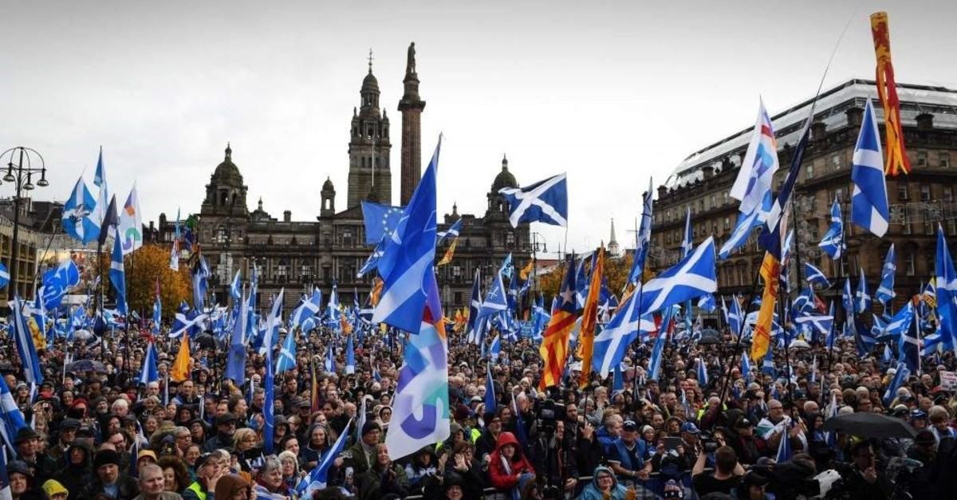

## **Historical background and current situation**

The issue of Scottish independence has deep historical roots. The Acts of Union in 1707 united Scotland and England, forming Great Britain. That happened because after the First English Civil War, the leaders at the time saw the union of Scotland and England as beneficial for free trade and to preserve the Presbyterian kirk. But since that time it was met with revolts and protests from both sides, as they lacked support, it was ignored. Scotland has been arguing for years that Independence would, according to their government: “give us the chance to contribute more on issues like international development, climate change and the environment. Scotland already makes a contribution on the world stage, where we can”.

The modern movement for Scottish independence gained the spotlight and recognition in the late 20th century, especially after the establishment of the Scottish National Party (SNP) in 1934. The SNP's primary goal has been to achieve full independence for Scotland, a hard fight **now that, in 2014**, the year is deemed to have the most power to achieve its independence. On 1 July 1999, after two referendums, the Scotland Act established the Scottish Parliament, granting Scotland a measure of self-governance.

As the SNP won an outright majority of seats at the 2011 Scottish Parliament election, it created some local conflicts that led to an agreement between the Scottish and UK governments to hold the 2014 Scottish Independence referendum. Voters were asked: "Should Scotland be an independent country?".

‘Better Together’ was a party campaign for Scotland to remain part of the UK during the 2014 referendum. The campaign was launched on June 25, 2012 and chaired by Alistar Darling. The campaign wanted to show the people in Scotland the advantages of staying in the UK and was made together with the Labour party.

In contrast to ‘Better together’, the pro-independence campaign, ‘Yes Scotland’, led by Alex Salmond of the Scottish National Party (SNP), was created. Salmond argues for Scotland's right of self-governance and economic control, including managing North Sea oil revenues. Even with Scoland partial autonomy, the question of full independence remained. Now that, in 2014, the referendum for the Scottish exit of the UK is being debated, the MPs will together create Bills (laws) on if Scotland will stay at the House of Commons and what measures should all the citizens take in order to prevent further protests from happening.

## **Timeline of events**

1979 - A referendum on devolution (the transfer of powers and funding from national to local government) was held but failed due to a 40% electorate threshold not being met.

1999 - The Scotland Act established the creation of a Scottish Parliament and the first elections for the Scottish Parliament happened

2011 - The Scottish National Party (SNP) won a majority in the Scottish Parliament with 69 seats and wanted an independence referendum.

2012 - The Edinburgh Agreement was signed by the Scottish and UK governments, allowing for a legally binding referendum on Scottish independence.

November 2013 - The Scottish Government published "Scotland's Future," a white paper outlining plans for independence.

March 2014 - Major UK political parties ruled out a formal currency union with an independent Scotland.

September 2014 -This committee is historical and taking place in 2014, the House of commons is reunited to discuss the referendum.

## Position of Major Representatives

### Against the Independence

**Alistair Darling (Labour)**

Alistair Darling was born in 1953 and he was a member of Parliament (MP) from 1987 to 2015, representing Edinburgh Central and Edinburgh South West. He joined the Labour Party at 23, in 1977 and Darling was chairman and director of the Better Together campaign, voting for a "No" vote in the 2014 Scottish independence referendum. He was one of the most important people for the campaign and delivered a speech in 2012 at its inauguration.

**Douglas Alexander (Labour)**

Douglas Alexander is a politician from the Labour Party in the UK. He served as an MP for Paisley and Renfrewshire South starting from 1997, he said in the referendum: "Let us reject a damaging divorce, and instead vote for the best of both worlds: More of the decisions that matter to Scots being taken here in Scotland, backed up by the strength, stability and security of the UK." His stance is rooted in a belief that Scotland's interests are best served within the United Kingdom

**Johann Lamont (Labour)**

Johann Lamont born on July 11, 1957, is a Scottish Labour politician. She served as Leader of the Scottish Labour Party from 2011 to 2014, previously holding positions as a junior Scottish Executive minister and Deputy Leader of the Scottish Labour Party. She campaigned for Scotland to remain part of United Kingdom, emphasizing the potential economic risks and political uncertainties that independence could bring. Lamont argued that the union provided stability and significant economic benefits that an independent Scotland might not sustain

**James Gordon Brown (Labour)**

James Gordon Brown, born on February 20, 1951, is a British politician who served as Prime Minister and leader of the Labour Party from 2007 to 2010. He became leader of the Labour Party on June 24, 2007, and assumed the role of Prime Minister on June 27, 2007. He was also Chancellor of the Exchequer from 1997 and has been a member of parliament since 1983.

**Edward Samuel Miliband (Labour)**

Edward Samuel Miliband, born in 1969, is a British politician and Member of Parliament for Doncaster North since 2005. He was the Leader of the Labour Party and Leader of the Opposition from 2010 to 2015. Throughout the campaign, Miliband and other Labour figures highlighted the risks they believed independence posed to Scotland, such as the uncertainty regarding currency, EU membership, and the future of public services like the NHS

**Sir Iain Duncan Smith (Conservative)**

Iain Duncan Smith, often known by his initials IDS, is a British politician who served as Leader of the Conservative Party and Leader of the Opposition from 2001 to 2003. He was also Secretary of State for Work and Pensions from 2010. He has been the Member of Parliament for Chingford and Woodford Green since 1992. He warned that an independent Scotland would face significantly higher costs for benefits and pensions due to an ageing population and SNP policy pledges.

**Ruth Davidson (Conservative)**

Ruth Davidson is a Scottish politician, and was the leader of the Scottish Conservative Party from 2011 until 2014 (today). She also served as an MP for Glasgow and Edinburgh Central from 2011 and like her party, she opposes Scottish independence. Davidson has consistently warned that independence would create economic uncertainty and disrupt public services

**Liam Fox (Conservative)**

Liam Fox studied medicine at the University of Glasgow and had a career as a GP and civilian army medical GP before becoming an MP. He held various ministerial positions under John Major and served as the Shadow Foreign Secretary and Shadow Defence Secretary. In the 2009 expenses scandal, he had the largest over-claim on expenses among Shadow Cabinet ministers.

**David Cameron (Conservative)**

David Cameron, born in 1966, is the current UK's Prime Minister from 2014. He led the Conservative Party and served as the Leader of the Opposition. Cameron wants a vision for one-nation conservative views and support for liberal policies. He played a crucial role in the "Better Together" campaign, emphasizing the benefits of the union and warning of the economic and social uncertainties that independence could bring. Cameron promised increased powers for Scotland's government if voters rejected independence

**(Liberal Democrats)**

**Jo Swinson (Liberal Democrats)**

Jo Swinson attended the London School of Economics before becoming the youngest MP at the time. She held various roles as a Liberal Democrat Spokesperson such as Women and Equalities, Communities and Local Government, and Foreign and Commonwealth Affairs.

**Michael Kevin Moore (Liberal Democrats)**

Michael Kevin Moore, born in 1965, is a British Liberal Democrat politician who was raised in Scotland but born in Northern Ireland. He became a member of parliament in 1997 and has held various portfolios, most importantly about Defense, which he believes is one of the most important topics in the referendum. He was also Secretary of State for Scotland until 2013.

**Menzies Campbell (Liberal Democrats)**

Menzies Campbell is a former athlete, having sports as his passion. He joined the Liberal Democrats in 2007 and is the Member of Parliament (MP) for North East Fife from 1987. He proposed a vision where Scotland would have significant self-governing powers while remaining part of the UK.

**Alistair Carmichael (Liberal Democrats)**

Alistair Carmichael was Liberal Democrat Chief Whip of the House of Commons from 2010 to 2013, then served as Secretary of State for Scotland in the Conservative-Lib Democrat coalition government until 2014. He argues that Scotland benefits significantly from being part of the United Kingdom

**Malcolm Gray Bruce (Liberal Democrats)**

Malcolm Gray Bruce, Baron Bruce of Bennachie, is a British Liberal Democrat politician who served as the Member of Parliament for Gordon from 1983 to 2015. He was chairman of the International Development Select Committee and deputy leader of the Liberal Democrats. He was appointed to the House of Lords in 2015 and was also President of the Scottish Liberal Democrats before being succeeded in 2016.

**Sir Daniel Grian Alexander (Liberal Democrats)**

Daniel Grian Alexander was a former politician who served as Chief Secretary to the Treasury from 2010 to 2015. He was the Member of Parliament for the Inverness, Nairn, Badenoch & Strathspey constituency from 2005 to 2015. During his first parliamentary term, he held various positions within the Liberal Democrat party, including spokesperson for Work and Pensions and Chief of Staff to party leader Nick Clegg.

### In Favor of the Independence (Scottish National Party)

**Alex Salmond (SNP)**

Alexander Salmond, born on December 31, 1954, is a Scottish politician, economist, and television host. He was the First Minister of Scotland from 2007 to 2014 and is a key figure in the Scottish nationalist movement. Salmond previously led the Scottish National Party from 1990 to 2000 and 2004 to 2014. He is one of the people who wants and has the power for independence to happen.

**Angus Robertson (SNP)**

Robertson was elected to the UK House of Commons in 2001 for the Moray constituency. He was Scotland's youngest MP and known as the "hardest working MP." Robertson served on committees and as the SNP's spokesman on Defence and International Relations. He made above-average contributions in the House of Commons. In 2006, Robertson gave a report to Swiss Senator Dick Marty detailing suspicious aircraft movements in Scotland.

**Angus MacNeil (SNP)**

In the 2001 general election, MacNeil ran as the SNP candidate in Inverness East, Nairn, and Lochaber, placing second. He was elected as the MP for Na h-Eileanan an Iar in 2005 with a 44.9% vote share and a majority of 1,441. MacNeil gained attention in 2006 for his complaint to the Metropolitan Police about the Cash for Peerages scandal. He also called for the suspension of House of Lords appointments following the scandal. In 2006, he won the Best Scot at Westminster award for investigating potential abuse of the honors system.

**Eilidh Whiteford (SNP)**

Eilidh Whiteford is a Scottish National Party politician who was the MP for Banff and Buchan from 2010. She served as the SNP spokesperson for Women, Fishing, Food and Rural Affairs, and International Development in the 2010 forwards Parliament, and as the Spokesperson for Social Justice, Work and Pensions. he understood that with independence, work would be better in Scotland.

**Katy Clark (SNP)**

Kathryn Sloan Clark, Baroness Clark of Kilwinning, is a British politician and life peer who has been a member of the Scottish Parliament for West Scotland since 2021. Previously, she served as a Member of Parliament for North Ayrshire and Arran from 2005 to 2015 as a member of the Labour Party.

**Keith Brown (SNP)**

He was Minister for Schools and Skills. He is a member of the Scottish National Party and has been a vocal advocate for various progressive policies during his time in office, one of those being the independence of Scotland

**Mike Weir (SNP)**

In 2001, he was elected to Parliament as the SNP Spokesperson on Trade and Industry and Work and Pensions, and served on the Scottish Affairs Select Committee until 2005. He won the Angus seat in 2005 with a majority of 1601, despite starting with a notional majority of only 532. He is in favor of the independence as he believes that Industry will be fermented with the independence.

**Nicola Sturgeon (SNP)**

Sturgeon served as Leader of the Opposition in the Scottish Parliament from 2004 to 2007 before becoming deputy to Alex Salmond in the SNP minority government. She then served as health secretary from 2007 to 2012, tackling issues such as prescription charges and the swine flu pandemic. Sturgeon was later appointed Cabinet Secretary for Infrastructure and played a key role in the 2014 Scottish independence referendum. She is still not the leader of the SNP.

**Pete Wishart (SNP)**

Peter Wishart, a Scottish National Party politician and musician, has been the MP for Perth and North Perthshire since 2001. He currently serves as the SNP Shadow Leader of the House in the House of Commons and chairs the Scottish Affairs Select Committee. Wishart has also held various positions within the SNP and was a keyboard player for Runrig and Big Country.

**Stewart Hosie (SNP)**

Stewart Hosie, a Scottish National Party politician, was the MP for Dundee East from 2005 to 2024. He also held roles as the SNP Shadow Chancellor of the Duchy of Lancaster and Shadow Minister for the Cabinet Office and served as Deputy Leader of the SNP to Nicola Sturgeon from 2014. He states: “We don't need hope from the SNP – what we need is action”

## **Guiding questions**

* Should Scotland leave the United Kingdom?
* What does your party defend?
* What are the benefits / losses if Scotland leaves the UK?
* Research what the state the MP represents wants, and what the Member’s personal interests and issues regarding Scottish Independence are.

**Further research**

* <https://www.theguardian.com/politics/scottish-independence>
* <https://www.parliament.uk/business/publications/research/scotland-the-referendum-and-independence/>
* <https://www.gov.uk/government/topical-events/scottish-independence-referendum/about>
* <https://commonslibrary.parliament.uk/research-briefings/cbp-9104/>

# 

# 

# **BIBLIOGRAPHY**

“Building a New Scotland: an independent Scotland in the EU.” *The Scottish Government*, 17 November 2023, https://www.gov.scot/publications/building-new-scotland-independent-scotland-eu/. Accessed 31 July 2024.

“Johann Lamont.” *Scottish Parliament*, https://www.parliament.scot/msps/current-and-previous-msps/johann-lamont. Accessed 31 July 2024.

McInnes, Roderick. “Scottish Independence Referendum 2014 - House of Commons Library.” *The House of Commons Library*, 30 September 2014, https://commonslibrary.parliament.uk/research-briefings/rp14-50/. Accessed 31 July 2024.

Roy, Graeme, and Stuart McIntyre. “Scottish independence: what are the big economic questions?” *Economics Observatory*, 24 January 2022, https://www.economicsobservatory.com/scottish-independence-what-are-the-big-economic-questions. Accessed 31 July 2024.

“Scottish independence.” *The Guardian*, https://www.theguardian.com/politics/scottish-independence. Accessed 31 July 2024.

“Scottish independence: How did we get here and what happens next?” *BBC*, 15 October 2023, https://www.bbc.com/news/uk-scotland-scotland-politics-67063555. Accessed 31 July 2024.

“Scottish independence referendum.” *UK Parliament*, https://www.parliament.uk/business/publications/research/scotland-the-referendum-and-independence/. Accessed 31 July 2024.

“Scottish independence referendum.” *GOV.UK*, 18 September 2014, https://www.gov.uk/government/topical-events/scottish-independence-referendum/about. Accessed 31 July 2024.

Torrance, David. “Scottish independence referendum: legal issues - House of Commons Library.” *The House of Commons Library*, 10 January 2023, https://commonslibrary.parliament.uk/research-briefings/cbp-9104/. Accessed 31 July 2024.